Table of Contents
CHAPTER 1: INTRODUCTION 3
2.1 Background 4
2.2 Brief history of Technology/concept 5
2.3 Architecture and characteristics 6
2.4 Applications 8
2.5 Research motivation and Problem statement 9
2.5.1 Research Motivation 9
2.5.2 Statement of the Problem 10
2.6 Research objectives and contributions 12
2.6.1 Primary objectives 12
2.6.2 Main contributions. 12
2.7 Organization of the report 13
CHAPTER 2 : RELATED WORK 14
3.1 Introduction 14
3.2 Previous work performed in the given domain: 15
3.3 Explain Protocols, algorithms and domains: 17
2.4 Benefits: 17
2.4 Summary: 18
CHAPTER 3: SYSTEM REQUIREMENTS SPECIFICATIONS 20
3.1 General Description. 20
3.1.1 Product Perspective. 20
3.2 Functional Requirments 21
Raspberry Pi 3: 21
LM35 Sensor Specification: 22
Temperature and Humidity Sensor: 23
Water Level Sensor 24
Soil Moisture Sensor 25
3.3 Non-functional Requirements 26
Performance Requirements 26
Safety Requirements 26
3.4 Summary. 26
CHAPTER 4: DESIGN 27
4.1 Architectural Design. 27
4.2 Usecase Diagrams 28
4.3 Database Design. 29
CHAPTER 5: IMPLEMENTATION 30
5.1 Methodology: 30
5.2 Pseudo code 31
CHAPTER 6:TEST CASES……………………………………………………………………33
CHAPTER 7:RESULTS: 36
7.1 SOFTWARE 36
7.2 HARDWARE 40
CHAPTER 8: 41
CONCLUSION 41
FUTURE WORK 41
CHAPTER 9: REFERENCES 42

APPENDIX 1 Paper
APPENDIX 2 Plagiarism Report

LIST OF FIGURES
Figure 1: SYSTEM ARCHITECTURE 8
Figure 2: RASPBERRY PI 3 22
Figure 3: LM 35 23
Figure 4: DH 11 SENSOR 24
Figure 5: WATER LEVEL DETECTOR 25
Figure 6: SOIL MOISTURE SENSOR 26
Figure 7: ARCHITECTURAL DESIGN 28
Figure 8: USE CASE DESIGN 29
Figure 9: DATABASE DESIGN 30
Figure 10: SOFTWARE REPRESENTATION 37
Figure 11: The channel id of Things speak 38
Figure 12: GRAPHICAL REPRESENTATION 39
Figure 13: HARDWARE REPRESENTATION....................................................................41

CHAPTER 1: INTRODUCTION
Internet of Things (IoT) is widely used in connecting devices and collecting data information. Internet of Things is used with IoT frameworks to handle and interact with data and information. In the system users can register their sensors, create streams of data and process information. IoT are applicable in various methodologies of agriculture. Applications of IoT are Smart Cities, Smart Environment, Smart Water, Smart Metering, Security and Emergency, Industrial Control, Smart Agriculture, Home Automation, e-Health etc. ‘Internet of Things’ is based on device which is capable of analysing the sensed information and then transmitting it to the user.
From survey of United Nations - Food and Agriculture Organisations, the world wide food production should be increased by 70% in 2050 for evolving population. Agriculture is the basis for the human species as it is the main source of food and it plays important role in the growth of country's economy. It also gives large ample employment opportunities to the people. The farmers are still using traditional methods for agriculture, which results in low yielding of crops and fruits. So the crop yield can be improved by using automatic machineries. There is need to implement modern science and technology in the agriculture for increasing the yield. By using IoT, we can expect the increase in production with low cost by monitoring the efficiency of the soil, temperature and humidity monitoring, rain fall monitoring, fertilizers efficiency, monitoring storage capacity of water tanks and also theft detection in agriculture areas.
The combination of traditional methods with latest technologies as Internet of Things and Wireless Sensor Networks can lead to agricultural modernization. The Wireless Sensor Network which collects the data from different types of sensors and send it to the main server using wireless protocol. There are many other factors that affect the productivity to great extent. Factors include attack of insects and pests which can be controlled by spraying the proper insecticide and pesticides and also attack of wild animals and birds when the crop grows up. The crop yield is declining because of unpredictable monsoon rainfalls, water scarcity and improper water usage.

Background
India is an agricultural country and ranks second in farm output worldwide. Agriculture being the basic source of living of people in India, greenhouses are one of the very important aspect of agricultural and horticultural sectors. Plants are allowed to grow under favourable climatic or environmental conditions for better production as well as growth. Hence controlling and monitoring of greenhouse environment is essential for management and production of greenhouses. This project is developed to monitor and control the humidity and environment conditions that affect the plants using embedded system and IOT. There are number of factors that are responsible for the crop rate. It may be due to water scarcity, soil fertility, climatic changes or diseases etc. The integration of IOT with wireless sensor networks is one of the solutions to effectively monitor the conditions. IOT involves a three-tier system, which includes perception layer, network layer and the application layer. Perception layer includes sensor motes. Information communication technology (lCT) enabled devices, sensor motes are building blocks of sensor technology. It includes cameras, RFID tags, sensors and sensor network used to recognize objects and collecting real time information. The network layer is a infrastructure of the lOT to realize universal service. It directs towards the combination of the perception layer and application layer. The application layer is a layer that combines the lOT with the technology of specific industry. The internet of things almost applied in all areas of industry, including smart agriculture, smart parking, smart building environmental monitoring, healthcare transportation and many more. Among them, agriculture is one of the important areas which targets millions of people.

Brief history of Technology/concept
Food production technology has continuous increase in demand. Economy is dependent on agricultural produce in a country like India. Food production Demand can be satisfied by Agricultural means. Because of isotropic environmental conditions, scarcity of water, production from agriculture does not meet the demands. Nowadays, agriculturists have been using various irrigation techniques for increasing the production. Human intervention is used to achieve these techniques. But due to manual work involved, sometimes either the plants require more water or water might reach late up to the length of the plants. This will affect the plant growth. There are many such problems associated with it. To overcome from these complications, automatic micro controller based system can be used. Automatic monitoring of the conditions can be achieved by developing embedded system which will record the temperature, light availability, water level and humidity. An open source IOT application is used to analyse the climatic conditions after data acquisition.

Architecture and characteristics
A system architecture or systems architecture is the conceptual model that defines the structure, behavior, and more views of a system. An architecture description is a formal description and representation of a system, organized in a way that supports reasoning about the structures and behaviors of the system.
System architecture can comprise system components, the externally visible properties of those components, the relationships between them. It can provide a plan from which products can be procured, and systems developed, that will work together to implement the overall system. There have been efforts to formalize languages to describe system architecture; collectively these are called architecture description languages.

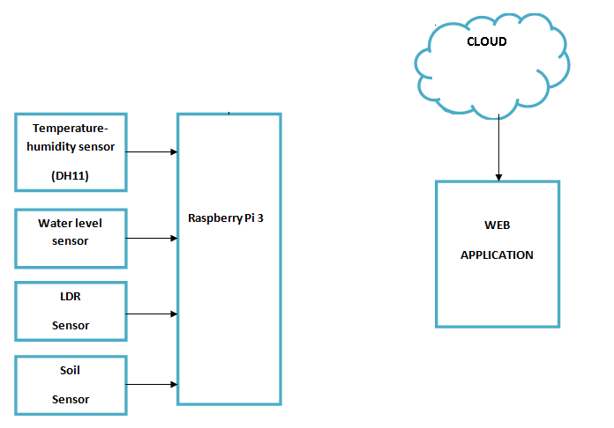
Figure 1: SYSTEM ARCHITECTURE
Smart agriculture using IOT consists of three levels:
1. Level 1 consists of the sensor part
2. Level 2 consists of the cloud part
3. Level 3 consists of the user part

- Sensor part
It consists of the sensors which are connected to the raspberry pi. Temperature sensor which measures the analog values of the environment, humidity sensor measures amount of water in air, soil moisture sensor uses capacitance to measure dielectric permittivity of the surrounding medium. and therefore shows the water content of the soil.
- Cloud part
Cloud computing is a type of Internet-based computing that provides shared computer processing resources and data to computers and other devices on demand. It is a model for enabling ubiquitous, on-demand access to a shared pool of configurable computing resources (e.g., computer networks, servers, storage, applications and services), which can be rapidly provisioned and released with minimal management effort. Cloud computing and storage solutions provide users and enterprises with various capabilities to store and process their data in either privately owned, or third-party data centers that may be located far from the user–ranging in distance from across a city to across the world.
- User part
It is an android phone app is a Platform with iOS and Android apps to control Raspberry Pi and the likes over the Internet.

Applications
Accuracy Farming:
Accuracy farming is also called accuracy agriculture. Accuracy farming makes the farming practice more precise and controlled regarding the raise of livestock and growing of crops. A key component here is to use IT and various components like sensors, control systems, robotics and so on. Accuracy farming is considered to be one of the most well-known applications in agricultural sector of IOT. Numerous organizations are leveraging this technology worldwide. Crop Metrics is one of the accuracy agriculture organizations which mainly focus on ultra-modern agronomic solutions while specializing in the management of precision irrigation. In this project we deploy four sensors to collect data regarding humidity, temperature, water level and the availability of light. There is an open source IoT application which displays the graph for each characteristic of the environment based on the data gathered. Data is first sent to a microcontroller board and then the information will be resent to the cloud using Wi-Fi. This open source application can be installed on an android phone. Feeding the required credentials such as Read API Key and Write API Key, concerned person can draw inferences by the graphs shown on device that supports the application.

Research motivation and Problem statement

Research Motivation
There are many revolutions with respect to agricultural practices carried out by our farmers. It is suggested that agriculture is now undergoing a 4th revolution. This revolution is triggered by the exponential increase in the use of information and communication technology (ICT) in agriculture.
Autonomous objects have been developed for making the farming practices more easy and reliable. The development of unmanned practices together with the development of embedded technology has caught much attention in agricultural sectors.
Altogether, the technical improvements constitute a major portion to the technical revolution that has generated disruptive changes in agricultural practices. This trend in practices can be seen even in developing countries where the deployments in ICT are being adopted at a rapid pace and could be the reason for a change in the future. Pointing them out at an early stage of revolution to avoid lock-ins is one of the crucial tasks that have to done. Only if aspects of technology, diversity of crop and livestock systems, and networking and institutions (i.e. markets and policies), are considered jointly in the dialogue, should farming in the digital era be termed “smart farming.”

Statement of the Problem
This project is motivated by our farmers who work in the farm lands and solely depend on the bore wells and rains for irrigation of the land. In recent times, the farmers have been using several irrigation techniques which are performed through the manual control in which the farmers irrigate the land at regular intervals by turning the water-pump ON/OFF when required. They may be suffering from hot Sun, rain and night time too just to check the water level available for irrigation or any other parameters like light exposure, soil moisture, temperature.

- Autonomous environmental monitoring system using web application.
Favorable environment is essential for the growth of crops. Continuous monitoring is an important tool for management of production and providing real-time data to ensure crop growth. An affordable wireless environment monitoring system will enable cost-effective data collection, which enables farmers to ensure proper crop growth. In this project, a low-cost wireless environmental parameters sensing system is presented. The results indicate that with appropriate calibration, a reliable monitoring system can be established.
- Design of Smart Sensors for Real-Time Monitoring.
This paper describes work that has been done on design and development of a environmental monitoring system, with the objective of notifying the user of the real-time parameters. The system is able to measure the physiochemical parameters of environment, such as humidity, temperature, soil moisture, water level, and the light availability. These physiochemical parameters play an important role in the growth of crops. The sensors, which are designed from first principles and implemented with signal conditioning circuits, are connected to a microcontroller-based measuring node, which processes and analyses the data. The sensors are shown to work within their intended accuracy ranges. The results demonstrate that the system is capable of reading physiochemical parameters, and can successfully process, transmit, and display the readings.

Research objectives and contributions

Primary objectives
The objective of this project is to propose a Novel Smart Agriculture model based on IOT which assists farmers to get Live Data such as temperature, soil moisture, water content and light availability. This ensures efficient environment monitoring, enabling them to do smart farming and increase their overall yield and quality of products. The Agriculture model being proposed is integrated with Raspberry Pi Technology, Breadboard mixed with various sensors and live data feed can be obtained online from Thingsspeak.com.
IoT is basically the interconnection of devices. The main aim of Iot is to connect every object through internet. In this technology, every object is assigned a unique identifier, which ensures that each object can be accessed through the internet. It mainly focuses on incorporating devices and tools in order to display and alert the concerned users the advantages of wireless sensor network system. It aims at making agriculture smart using automation and IoT technologies. The objective of developing this system is to monitor the climatic condition of the crops in the field. The sensors are designed for collecting information about the climatic condition of the greenhouse like Temp, Pressure, Light and Humidity.

Main contributions.
This project contributes in developing smart agricultural practices using IOT. This project model helps the farmers to obtain the data without having to visit the field, using wireless communication. It records the essential parameters like temperature, humidity, water level and light which determine the crop growth. As agriculture accounts for almost 37% of GDP in India, strategies and planning are two important aspects that needs to be considered. Farmer or the concerned user can check the data acquired from the fields through the sensors in any device which supports IOT based application. Using login credentials, Read API and Write API keys one can log in to their account on any device. Hence it eases the work of the farmers when compared to manual monitoring. This ensures efficient environment monitoring, enabling them to do smart farming and increase their overall yield and quality of products.

Organization of the report
The following provides the description of how the report is organised:
Chapter 2: This chapter presents a brief overview of the related work on using strategies and planning in the field of agriculture, focusing mainly on using microcontroller and Iot applications. Moreover, Introduction Previous work in the chosen domain, protocols/algorithms/Domains and benefits are briefly discussed.
Chapter 3: In this chapter, we have discussed the system requirements specifications. This includes product perspective and user characteristics. As we know system is a combination of both hardware and software components. Hence we have described Software requirements and Hardware requirements separately. Functional and Non-functional requirements are discussed in brief. In functional requirements, the major services provided by the project model are described. Non-functional requirements include performance and safety requirements.
Chapter 4: This chapter outlines the designs that are incorporated in this project model. Designing at the earliest stages is one of the important steps .The term design includes Architectural, Use case and Database Design.
Chapter 5:.In this chapter, the process of implementing is briefly explained. It explains many methods used in a Internet of things are of study. It also describes process of implementation and the programming language that is used in program design.
Chapter 6: Test cases have been included to explain the different functionalities of the project model at different situations. Here, different situations are referred to various climatic conditions.
Chapter 7: Finally, this chapter summarizes the important points on which the project work is presented.
Chapter 8: This chapter explains the overall functions of the project together with a brief discussion which highlights possible directions for future research.
Chapter 9: In this chapter, the sources of information that are used to complete the project have been stated in order to ascertain the proposed information.

CHAPTER 2: RELATED WORK

Introduction

Agriculture, farming or husbandry is a vital occupation since the history of mankind is maintained. The name agriculture represents all entities that came under the linear sequence of links of food chain for human beings. As humans are the smartest living species on this planet, so their smartness always provokes them to change and to innovate. This provoking has led to invention of wheel, advancements in living standards and styles, languages, life spending methodologies and countless more achievements.
The restless attitude of mankind towards innovations has given birth to major inventions, which have not only provided the ease to human beings, but also improvements in efficiency which further lead to better productivity on the cost of less skills. The advancements in agriculture are necessary to balance the demand and supply as population is increasing day by day. As compare to the last fifty years and earlier, the demand of food has accelerated. To overcome the requirements, the deployment of modern technology over this vital source for humans is intolerable. With the use of modern and advanced technologies, efficiency of the agricultural industry can be improved, where it not only includes better productivity, but also lessens intra-field and inter-field losses present in conventional methods.
From the beginning, agriculture is crucial part of human society due to the reality that man and agriculture are directly related to each other. This fact leads towards the advancement and enhancement of the typical, inappropriate and time consuming methodologies, used for agriculture. The fast moving world, new trends and technological advancement has changed the life style of people. Emerging new technologies are becoming an important part of routine. Smart homes and grid, smart cities,smart campus, and smart farming are some of the whole advanced and upgraded, information and communication technologies that are helping humans to save time and get faster and aureate outcomes.
Multiple technologies like ubiquitous computing, wireless networks, RFID tags, after having advanced in other fields of life, due to their tremendous efficiency, are now also imposing the agriculture industry. Moreover, the coming era of IT equipped world will replace traditional methodology with smart, efficient and sustainable agriculture regime.
The advanced highly efficient, cost effective, sustainable, fast and aureate results have been the main factors which have invoked researchers’ to contribute towards smart agriculture. E-farming, smart fertilized mobilization, RFID tags for cattle monitoring, GPS field monitoring, sensor networks in farming, moisture and humidity detection, context aware computing, precious farming, web of things and livestock and ware house management applications, etc.; are some of the technological projects related to the smart farming regime.agriculture. Many countries like china, India, Korea, Brazil, Australia, several European countries and different American estates, are introducing agricultural technologies in order to strengthen their economy by using information and communication technologies for the improvement in agricultural and rural development.

Previous work performed in the given domain:
In paper[1] proposed an agricultural application of wireless sensor network for crop field monitoring. These systems fully equipped with two type sensor nodes to measure humidity, temperature, and an image sensing node to compare information by taking images of crops. Parameters play an important role for taking a good decision making for healthy crop within a time. The parameters are temperature, humidity, and images. By following these methods can achieve high stability of sensors with low consumption of power. With it’s a long period of monitoring the agriculture field area. Paper [2] proposed a greenhouse Monitoring System based on agriculture IoT with a cloud. In a greenhouse, management can monitor different environmental parameters effectively using sensor devices such as light sensor, temperature sensor, relative humidity sensor and soil moisture sensor. Periodically (30 seconds) the sensors are collecting information of agriculture field area and are being logged and stored online using cloud computing and Internet of Things. [3] Papers explain an IOT Based Crop-Field Monitoring and Irrigation Automation system. In their work, to monitor crop-field a system is developed by using sensors and according to the decision from a server based on sensed data, the irrigation system automated. By using wireless transmission the sensed data forwarded towards to web server database. If irrigation is automated then that means if the moisture and temperature fields fall below of the potential range. The user can monitor and control the system remotely with the help of application which provides a web interface to the user. In [4] proposed a smart drip irrigation system. In this, an Android mobile application is used to reduce the involvement of human and it used to control, monitor the crop area remotely. Water wastage can reduce with Drip Irrigation system and it works based on information from water level sensors. Some more different sensors are used to monitor the environmental conditions. [5] Proposed smart irrigation systems using Internet of Things. To calculate humidity and water levels of soil some wireless sensors are needed. These sensed data are sent to a smart gateway through a network, using a gateway called Generic IoT Border Router Wireless Br 1000. From the gateway, the data is then sending to a web service through a network.[6] To store the collected data here one database management is needed and it contains all soil information. Based on the temperature sensor values they have mainly focused on automatically controlling the water flow to the agricultural field. pre-prediction of rain can be done with the help of sensor to sense the weather condition, this will be intimated to farmer‘s smartphone for his references through GSM. In wireless sensor networks automatically analyze sensed data from agriculture area field by using intelligent software application and this will take a decision, that is forwarded to the farmer for a healthy crop.[7] in this paper author Proposed a low maintenance and high gain Agriculture using novel Eco-friendly and Energy Efficient Sensor Technology. this paper clearly explains about automated farm monitoring and irrigation techniques which include wide range of sensors to remotely sense and monitor various parameters of the soil like temperature, moisture, and fertility and controls the supply of water and fertilizer to the land.

Explain Protocols, algorithms and domains:
The protocols at the sensing end of IoT will play a key role in complete realisation. They form the backbone for the data tunnel between sensors and the outer world. For the system to work efficiently, and energy efficient MAC protocol and appropriate routing protocol are critical. Several MAC protocols have been proposed for various domains with TDMA (collision free), CSMA (low traffic efficiency) and FDMA (collision free but requires additional circuitry in nodes) schemes available to the user. None of them are accepted as a standard and with more things available this scenario is going to get more cluttered which requires further research. An individual sensor can drop out for a number of reasons, so the network must be self-adapting and allow for multi-path routing. Multi-hop routing protocols are used in mobile ad hoc networks and terrestrial WSNs. They are mainly divided into three categories - data centric, location based and hierarchical, again based on different application domains. Energy is the main consideration for the existing routing protocols. In the case of IoT, it should be noted that a backbone will be available and the number of hops in the multi-hop scenario will be limited. In such a scenario, the existing routing protocols should suffice in practical implementation with minor modifications.

2.4 Benefits:
Technology is improving the efficiency of agriculture, in terms of production and economic growth. This directly creates an impact on employment and labor opportunities, environmental sustainability, small holder income, good security and the price of food.
The spread of smart technologies in the field of farming has been impressive and is particularly contributing towards improved varieties in the production of grains. Advances in farm management technology have also become popular, in terms of providing accuracy and ease of management and security. Development of supporting infrastructure, high-tech irrigation, increased employment opportunities, increased production and decreased food price, nutrition and food utilization, access to land and other resources and the utilization of all available resources are some of the plus points of technology in agriculture. These all result in the transformed reformed economic growth for common man. Following is the table summarizing benefits provided by CSIRO documentation Smart Farming: leveraging the impact of broadband and the digital economy. In the agriculture Industry especially in under-developed countries the technological advancements are necessary. Although, it may not be very economic and may have financial constraints at the time of planning and deployment but if we talk about broader scope or of the fore vision of these advancements it will not only increase the net income of agriculture but also improve the quality of the production. As we know that the precise and time to time collection is not an easy task done by humans. Therefore technology will keep the farmers aware of each and every instance and the drift of the coordinates in some underneath areas which humans might miss to check and are able to take prompt action to relevant issues. These issues may be related to rain, parasites, condition of soil or humidity/dryness factor.

2.4 Summary:
we have discussed the importance of agriculture, it’s conventional as well as adopted methods and trends in the light of productivity and requirement of market. As all us can understand that production in every field must equal the demand and supply ends, which is certainly not possible without integration of technology in the field. Moving further we have disused the available technologies and platforms in wireless communication field, according to their data rates and most useful areas. Continuing with the wireless technologies we have also elaborated the concept of SMART and its relevance in the future for overcoming the necessity human engagement or appointment. As the chapter goes on the discussion continues on the available sensors for agriculture field as well as the wireless communication technologies those can be utilized in the field of agriculture. Moving on we have disused the issues and some of the proposed solutions in the light of Human behavior, agriculture, climate changes, market and the proper regulation.
Keeping in the vision that deployment is not as easy, as it is not accepted very easily by the consumer due to its pre-benefit cost, we have also a convincing discussion under the Socio economic challenges. At the end of it we have not only disused the advantages but also listed them in tabular form. The chapter is concluded on a short discussion on areas where advancements are required The proliferation of devices with communicating actuating capabilities is bringing closer the vision of an Internet of Things, where the sensing and actuation functions seamlessly blend into the background and new capabilities are made possible through access of rich new information sources. The evolution of the next generation mobile system will depend on the creativity of the users in designing new applications. IoT is an ideal emerging technology to influence this domain by providing new evolving data and the required computational resources for creating revolutionary apps. Presented here is a user-centric cloud based model for approaching this goal through the interaction of private and public clouds. In this manner, the needs of the end-user are brought to the fore. Allowing for the necessary flexibility to meet the diverse and sometimes competing needs of different sectors, we propose a framework enabled by a scalable cloud to provide the capacity to utilize the IoT. The framework allows networking, computation, storage and visualization themes separate thereby allowing independent growth in every sector but complementing each other in a shared environment. The standardization which is underway in each of these themes will not be adversely affected with Cloud at its center. In proposing the new framework associated challenges have been highlighted ranging from appropriate interpretation and visualization of the vast amounts of data, through to the privacy, security and data management issues that must underpin such a platform in order for it to be genuinely viable. The consolidation of international initiatives is quite clearly accelerating progress towards an IoT, providing an overarching view for the integration and functional elements that can deliver an operational IoT.

CHAPTER 3: SYSTEM REQUIREMENTS SPECIFICATIONS

3.1 General Description.
The system requirements of a smart agriculture plan which is IOT based includes smart sensors to collect data. The data collected through these is sent to the application through an Raspberry Pi 3 connected to a remote access like a laptop or desktop. The web application running on the back end provides a user interface for the users to monitor the readings.

3.1.1 Product Perspective.
The product presented as a result of the project is a smart and enhanced web application which displays the data collected by various sensors in a pictorial graphical form. The product is aimed to increase the technology used in the agriculture to enhance the yield of crops by monitoring.
- Hardware requirements.
- Raspberry Pi 3
- Temperature and humidity sensor
- LDR – Light Detecting Resistor
- Water Level Sensor
- ESP8266 Wi-Fi Module

- Software requirements.
- Embedded ‘C’
- J2ME
- Things Speech Widget

3.2 Functional Requirments

Raspberry Pi 3:
The Raspberry Pi 3 microcontroller is an easy to use yet powerful single board computer that has gained considerable traction in the hobby and professional market. The Raspberry Pi 3 is open-source, which means hardware is reasonably priced and development software is free. The specifications are 1.4GHz 64-bit quad-core processor, dual-band wireless LAN, Bluetooth 4.2/BLE, faster Ethernet, and Power-over-Ethernet support.
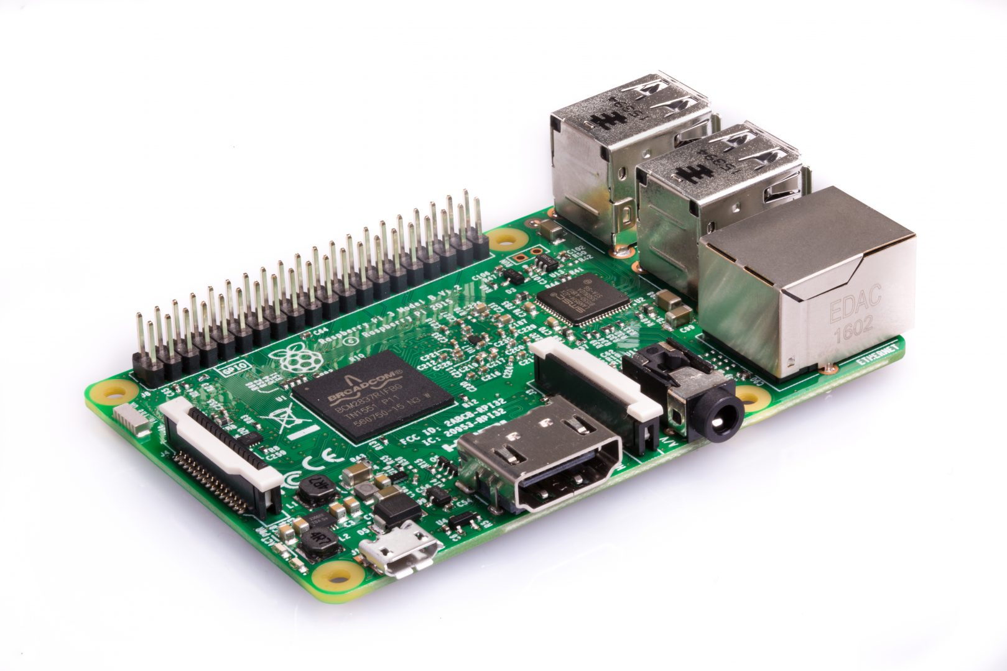
Figure 2: RASPBERRY PI 3

LM35 Sensor Specification:
The LM35 series are precision integrated-circuit LM35 temperature sensors, whose output voltage is linearly proportional to the Celsius (Centigrade) temperature. The LM35 sensor thus has an advantage over linear temperature sensors calibrated in ° Kelvin, as the user is not required to subtract a large constant voltage from its output to obtain convenient Centigrade scaling. The LM35 sensor does not require any external calibration or trimming to provide typical accuracies of ±¼°C at room temperature and ±¾°C over a full -55 to +150°C

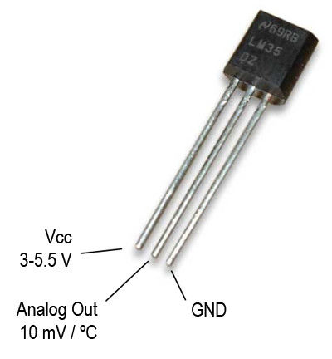
Figure 3: LM 35

Temperature and Humidity Sensor:
The DHT11 is a basic, ultra low-cost digital temperature and humidity sensor. It uses a capacitive humidity sensor and a thermistor to measure the surrounding air, and spits out a digital signal on the data pin (no analog input pins needed). Its fairly simple to use, but requires careful timing to grab data. The only real downside of this sensor is you can only get new data from it once every 2 seconds, so when using our library, sensor readings can be up to 2 seconds old.
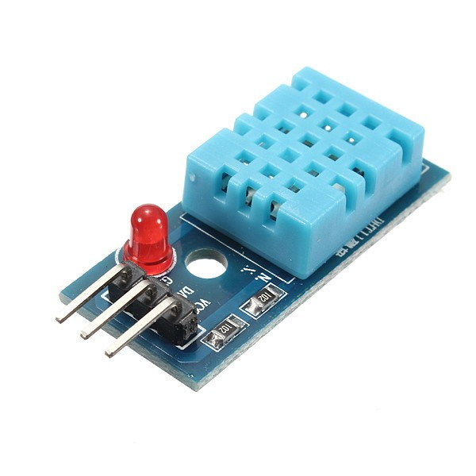
Figure 4: DH 11 SENSOR

Water Level Sensor:
A float switch is a type of level sensor, a device used to detect the level of liquid within a tank. The switch may be used to control a pump, as an indicator, an alarm, or to control other devices.
One type of float switch uses a mercury switch inside a hinged float. Another common type is a float that raises a rod to actuates a micro switch.
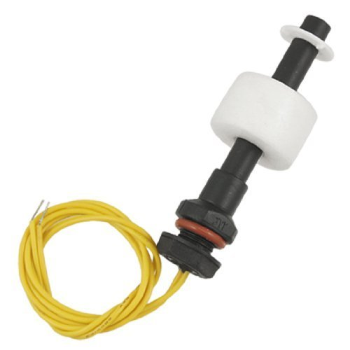

Figure 5: WATER LEVEL DETECTOR

Soil Moisture Sensor
The Soil Moisture Sensor uses capacitance to measure the water content of soil (by measuring the dielectric permittivity of the soil, which is a function of the water content). Simply insert this rugged sensor into the soil to be tested, and the volumetric water content of the soil is reported in percent.
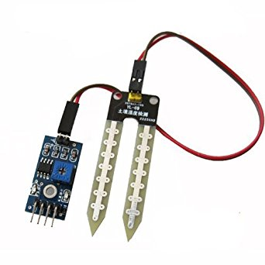
Figure 6: SOIL MOISTURE SENSOR

3.3 Non-functional Requirements
The non-functional requirements describes about the applications requirements on performance and safety as shown below.

Performance Requirements
To increase the performance the application the data is sent every 2 seconds and the data is collected effectively for better monitoring.
To increase the performance of hardware, the components are checked for faults at regular time intervals.

Safety Requirements
The application is user friendly and the hardware components are safe to use since the voltage level requirements are minimal which makes it more efficient.

3.4 Summary.
There is continuous increase in demand for food production technology. India is a country where the economy is dependent on agricultural produce. Agricultural means can satisfy the food production demand. But due to isotropic climatic conditions, lack of water reservoir, agricultural produce does not meet the demands. At the present scenario, farmers have been using different irrigation technique for increasing production. These techniques were done by human intervention. But due to this sometimes either the plants consume more water or the water reaches late up to the plants. This ultimately affects the plant growth. Also there are many such problems associated with it. To overcome from this problem, we can use an automatic micro controller based system. For automatic monitor and control we are developing an embedded system which will record the temperature, moisture and other parameters that will control the environmental conditions in the plant field. Moreover for effective control, an android application is used along with embedded system.

CHAPTER 4: DESIGN

4.1 Architectural Design.
The parameters can be monitored on android smart phone and also the relevant output devices can be controlled through Internet and We are Monitoring the entire system by using the Wi-Fi Module and The sensors will give the status and that are displayed in the things speech like platform of web page in the form of graphs new can update the data in the application, we manage the things wirelessly.

DH 11

SOIL MOISTURE
Raspberry pi 3
Thingspeak
LDR

WATER LEVEL
Web application
Android App

Figure 7: ARCHITECTURAL DESIGN

4.2 Usecase Diagrams
The results are represented in graphical for the user as shown below:

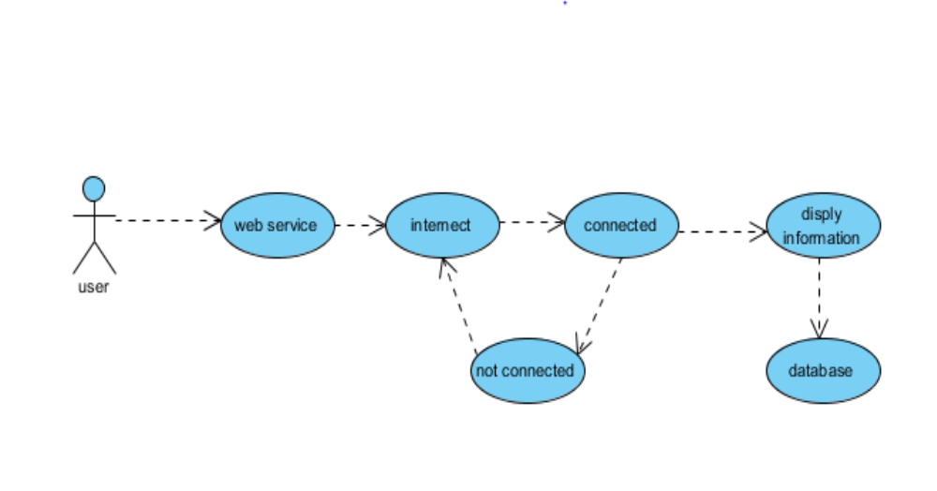

Figure 8: USE CASE DESIGN
The above diagram represents the four fields which shows first the humidity and the second graph shows the LDR sensor readings, the third graph shows the water level , which in the above case is constant, the fourth graph shows the temperature reading which in this case is first increasing and then dropping to the initial level and again increasing.

4.3 Database Design.
The database is created on the cloud which saves the data of each and every field on each day and the reading is evaluated to benefit the growth of crops.
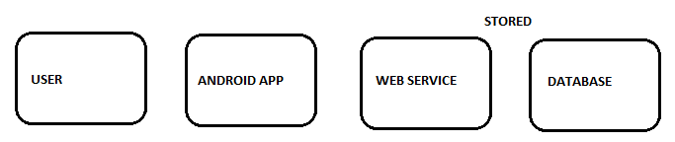
Figure 9: DATABASE DESIGN
The above data collected from the database describes the data collected on the date specified on the left and the respective readings of each sensor based on the field column mentioned.

CHAPTER 5: IMPLEMENTATION

5.1 Methodology:
To a great extent, the platform design addressed the unique challenges in building commercial scale IoT systems, identified in Section 3. Below is a summary of our experience and lessons learnt from building a system for smart farming. Support for virtually any IoT device: The key challenge that we faced in developing the SmartFarmNet platform was managing the plethora of Internet of Things devices, ranging from wireless sensor networks to mobile smart phones to cameras, etc. Our solution was to focus on developing common interfaces (API) and consistent representation of sensors and their data using semantic web technologies and thus moving away from the traditional packaged hardware/software solutions. By using a consistent way of representing data and providing different means to ingest data into the system (from API to wrappers built in Java, Python, R, etc.), we were able to interoperate between IoT hardware silos. Sensors 2016, 16, 1884 16 of 17 Provide rapid analysis of data in real-time: One fundamental challenge that underpinned most IoT platforms was in their ability to perform fast analysis of data over a large number of sensor data streams. By employing real-time statistical data analysis, the SmartFarmNet platform was able to achieve this objective. The platform incorporates a scalable methodology, delivering near real-time query response time as compared to traditional SQL-based systems [4].
Integration with Semantic Web: By using the semantic web technologies such as ontologies and linked open data, we were able to 1) use currently available semantic web standards, allowing the system to exchange data with other IoT services in the internet; and 2) enforce standards in IoT application development that is currently not prevalent in most existing solutions. Using the semantic web technologies also enabled the platform to be easily extended to new domains, such as aquaculture, cotton growing, etc. In certain cases, Thinkspeak was also used as a diagnostic tool to understand the performance of the underlying sensor network and detect failures using a pre-computed error estimate for each sensor. Thinkspeak approach for visualisation and analysis of data: The design objective of Thinkspeak was to empower its users by providing standard tools combined with a flexible and powerful API. By employing a do-it-yourself approach, Thinkspeak has reached a wider set of users and enabled them to collect crop performance data with any sensor(s). The ability for a farmer to explore and analyse crop growth data using simple selection based on familiar concepts such as crop phenotype, treatment, etc., was very useful in breaking many barriers to the Thinkspeak uptake

5.2 Pseudo code:
# Import all the libraries we need to run
import sys
import RPi.GPIO as GPIO
import os
from time import sleep
import Adafruit_DHT
import urllib2
DEBUG = 1
# Setup the pins we are connect to
RCpin = 24
DHTpin = 3
LDR=2
WL=4
SM=17
#Setup our API and delay
#myAPI = "LU7ZSVJD2AQH3WMW"
myAPI = "A0QOKYADDYVD61MS"
myDelay = 5 #how many seconds between posting data

GPIO.setmode(GPIO.BCM)
GPIO.setup(RCpin, GPIO.IN, pull_up_down=GPIO.PUD_DOWN)
GPIO.setup(LDR, GPIO.IN)
GPIO.setup(SM, GPIO.IN)
GPIO.setup(WL, GPIO.IN, pull_up_down=GPIO.PUD_UP)
def getSensorData():
RHW, TW = Adafruit_DHT.read_retry(Adafruit_DHT.DHT11, DHTpin)
#Convert from Celius to Farenheit
TWF = 9/5*TW+32
# return dict
return (str(RHW), str(TW),str(TWF))
def RCtime(RCpin):
LT = 0
if (GPIO.input(RCpin) == True):
LT = 1
return (str(LT))
def LDRSENS(LDR):
LD = 0
if (GPIO.input(LDR) == False):
LD = 1
return (str(LD))
def SMSENS(SM):
SMS = 0
if (GPIO.input(SM) == False):
SMS = 1
return (str(SMS))
def WLSENS(WL):
W = 0
if (GPIO.input(WL) == True):
W = 1
return (str(W))
# main() function
def main():
print 'starting...'
baseURL = 'https://api.thingspeak.com/update?api_key=%s' % myAPI
print baseURL
while True:
try:
RHW, TW, TWF = getSensorData()
#LT = RCtime(RCpin)
LD = LDRSENS(LDR)
W = WLSENS(WL)
SMS=SMSENS(SM)
f = urllib2.urlopen(baseURL +
"&field1=%s&field2=%s&field3=%s" % (LD,TW,RHW)+
"&field4=%s" % (W) +
"&field5=%s" % (SMS))
print f.read()
print LD + " " + TW+ " " + RHW + " " + W + " " + SMS
f.close()
sleep(int(myDelay))
except:
print 'exiting.'
break
if __name__ == '__main__':
main()

CHAPTER 6:TEST CASES:
Testing is a critical element of software and hardware quality assurance and represents the ultimate review of specification design and coding. Testing represents an interesting anomaly for the software and hardware. Thus, a series of tests are performed for the proposed system before the system is ready for user acceptance testing.

Once the software is validated, it must be combined with other system elements (e.g. Hardware, people and database). It verifies that all the elements are proper and that the overall system function performance is achieved. It also tests to find discrepancies between the system and its original objective, current specifications and system documentation.

During the course of the testing process, the program to be tested was executed with a set of test cases and the output of the program for the test cases were evaluated to determine if the program is performing as required. Errors and anomalies were detected by using these testing processes and corrected when encountered before complete system integration.
Here, the test cases and their expected outcomes which were conducted as part of the test plan developed for the system.

TEST CASE | 1
Name of the Module | Soil moisture sensor
Input Given | Testing for a given particular plant
Expected Output | Connected to Android Smart phone and web application with the presence of proper internet connection
Actual Output | Graph with the values shown indicating the soil moisture values for different time period
Result | Successful
TEST CASE | 2
Name of the Module | Web service
Input Given | Connected to the internet
Expected Output | Display the data n stored in cloud
Actual Output | Same as expected output
Result | Successful
TEST CASE | 3
Name of the Module | Database connection and fetching of data
Input Given | Set of tested data values
Expected Output | Application connects to the cloud and retrieves the data
Actual Output | Same as expected output
Result | Successful

TEST CASE | 4
Name of the Module | Android application
Input Given | Information about various parameters like the humidity ,soil moisture, temperature, water level, LDR sensor
Expected Output | Graph of the indicated data values stored in a data set and indicating the variation in the corresponding previous values
Actual Output | Graph indicating the set of data values retrieved from the cloud application
Result | Successful

CHAPTER 7: RESULTS:

7.1 SOFTWARE
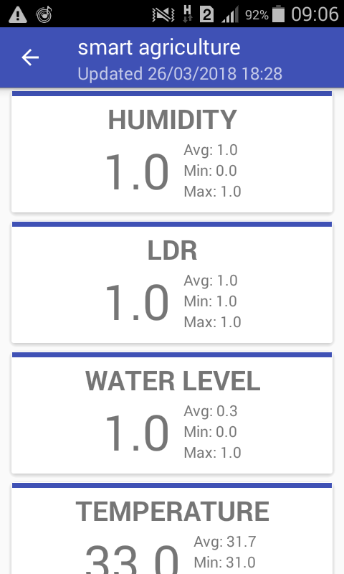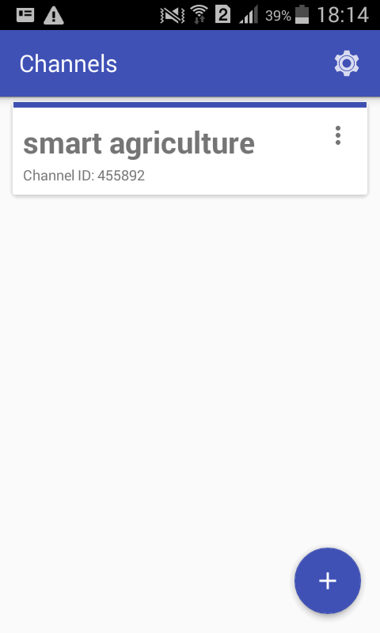

Figure 10: SOFTWARE REPRESENTATION
Thingspeak android application depicting the temperature,humidity,water level and amount of sunlight received by the sensors.

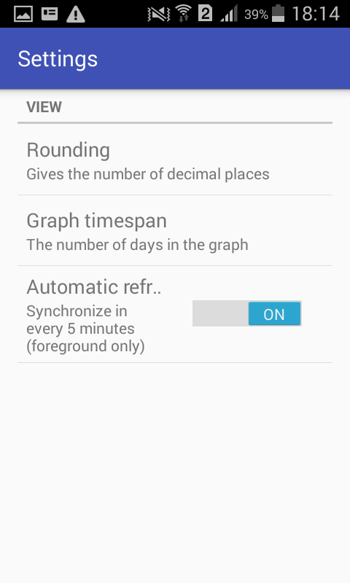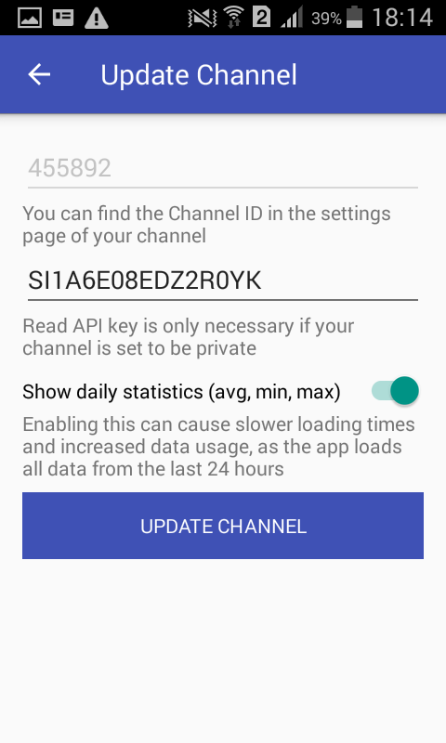
Figure 11: The channel id of Things speak

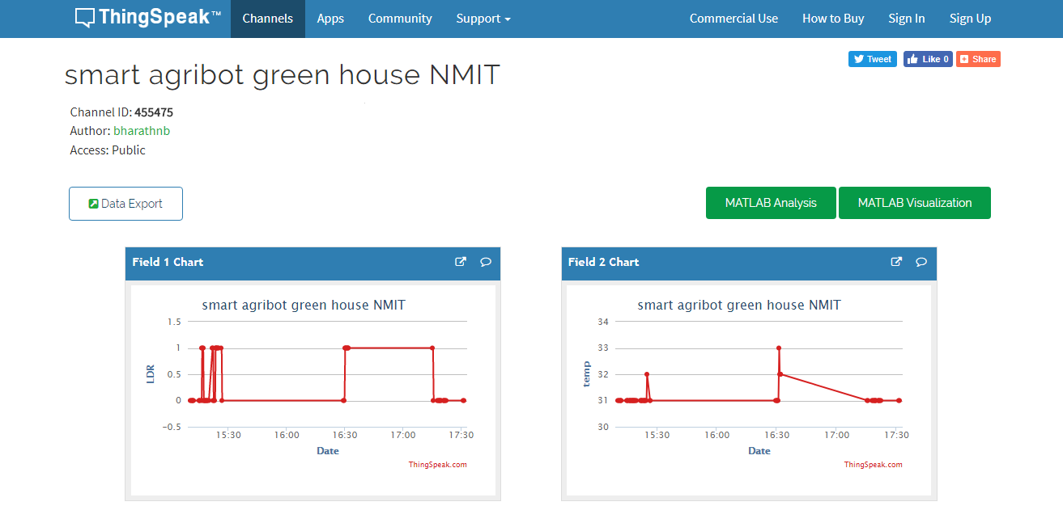
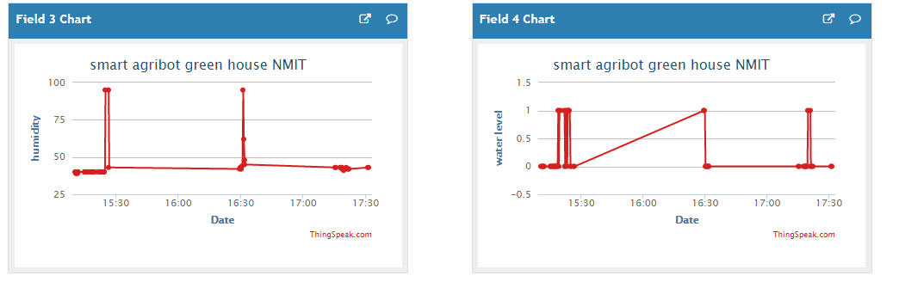
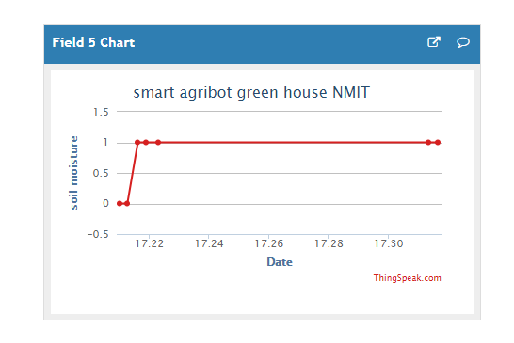Figure 12: GRAPHICAL REPRESENTATION
We have conducted the experiment and the graph is shown in the above picture. Five sensors are deployed in the fields. There are 5 fields i.e., Humidity, LDR, Water level,soil moisture and Temperature. It provides the graph based on the sensor data. We use various sensors to assist the condition of the green plant and sensor data will be sent to raspberry pi which is a mini computer, then green plant condition information will be updated to cloud simultaneously through WiFi and graph is shown in different fields of different sensors. Mobile application user or the concerned person can access the data at any time and anywhere. LDR sensor is used where there is a need to sense the presence(value 0) and absence(value 1) of light is necessary. Soil Moisture sensor determines the water content in the soil. Presence of water content in soil is determined by the value 1 from the sensor else value 0. Similarly, the results obtained by water level detector are of digital value. Value 0 corresponding to low water level and value 1 to high water level.

7.2 HARDWARE
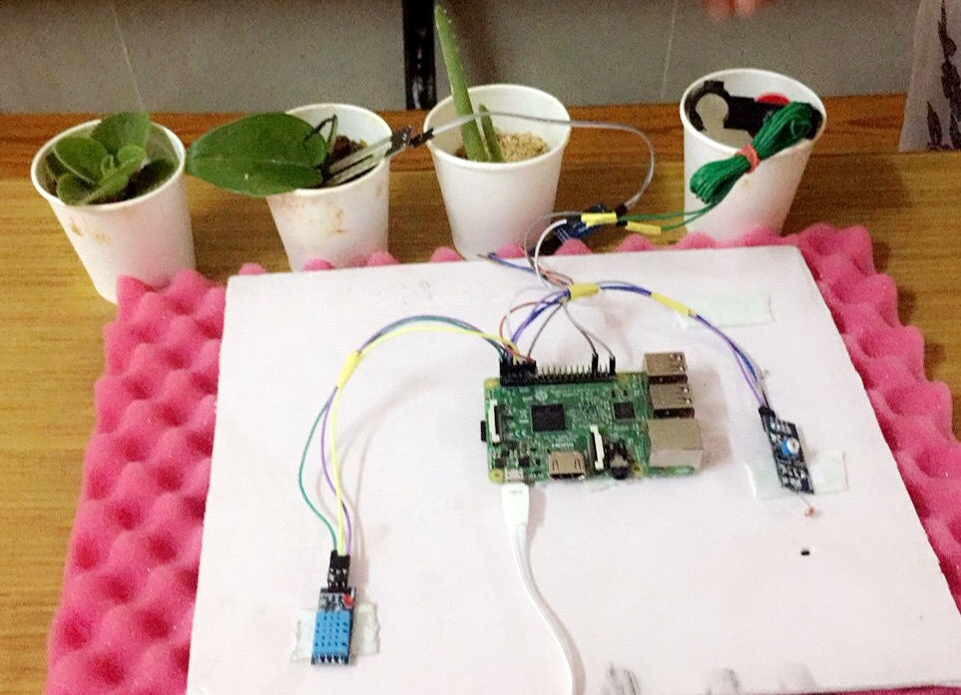
Figure 13: HARDWARE REPRESENTATION

CHAPTER 8: CONCLUSION
Adoption to this smart agriculture will improve the growth of agriculture where agriculture is the main production in India and the major income is from the agriculture industry to India. IoT based smart agriculture is very helpful for farmers. This is comparatively low cost. Distance is the main drawback in all the existing technologies. In intervals of time we need to visit the green house to check whether the conditions are favourable for the growth of plants. Using IoT we are overcoming this drawbacks and we can monitor as well as control the greenhouse from anywhere in the world if we have an internet connection in our smart phones. It controls and monitors the green house. The analog signals of sensors are converted into the digital values using microcontroller and the data from sensors give the environmental factors which is helpful for farmers. Implementation of such a system in the field can definitely help to improve the yield of the crops and overall production.
Thus, the IoT agricultural applications are making it possible for ranchers and farmers to collect meaningful data. Large landowners and small farmers must understand the potential of IoT market for agriculture by installing smart technologies to increase competitiveness and sustainability in their productions. The demand for growing population can be successfully met if the ranchers as well as small farmers implement agricultural IoT solutions in a successful manner.

FUTURE WORK
One of the limitation of this project is there is that internet connectivity is required to user and which is costly for farmers and this can overcome by extending the system to send notification via sms directly to the farmer on his mobile using GSM module instead of using mobile app. Weather data from the meteorological department can be used along with the sensed data to predict more information about the future which can help farmer plan accordingly to that and improve his livelihood.

CHAPTER 9: REFERENCES
[1]Shruti A Jaishetty, Rekha Patil, ʊIoT sensor network based approach for agricultural field monitoring and controlۅ .IJRET: International Journal of Research in Engineering and Technology, Volume: 05 Issue: 06 | Jun-2016.
[2] Keerthi.v , Dr.G.N.Kodandaramaiah, ʊ cloud IoT Based greenhouse Monitoring Systemۅ Int. Journal of Engineering Research and Applications ,ISSN: 2248-9622, Vol. 5, Issue 10, (Part - 3) October 2015, pp.35-41.
[3] Rajalakshmi.P, S.Devi Mahalakshmi , ʊIOT Based Crop-Field Monitoring and Irrigation Automation systemۅ . ieeexplore.ieee.org/iel7/7589934/7726872/07726900.
[4] Baltej Kaur , Danish Inamdar, Vishal Raut,Akash Patil,Nayan Patil, ʊ A Survey On Smart Drip Irrigation Systemۅ International Research Journal of Engineering and Technology (IRJET) Volume: 03 Issue: 02 | Feb-2016.
[5] G. Parameswaran, K.Sivaprasath, ʊ Raspberry Pi 3 Based Smart Drip Irrigation System Using Internet of Thingsۅ DOI 10.4010/2016.1348 ,ISSN 2321 3361 © 2016 IJESC.
[6] Gayathri.R, Saranya.B, Binu., Lavanya, Devi, ʊ Optimized Equipment for measurement of Soil Parameters and Conservation of Water in Agricultural Fieldsۅ.,International Journal of Innovative Research in Computer and communication Engineering,Vol.4,Issue 6,June 2016.
[7] Srisruthi.S, N.Swarna, G.M.Susmitha Ros, Edna Elizabeth ,ۅSustainable Agriculture using Eco-friendly and Energy Efficient Sensor Technologyۅ,IEEE International Conference On Recent Trends In Electronics Information Communication Technology,May 2016

